***Alecu Russo Balti State University***

***Republic of Moldova***

MITI 2018 19-21 April

**ULS**

You are welcome to join us!

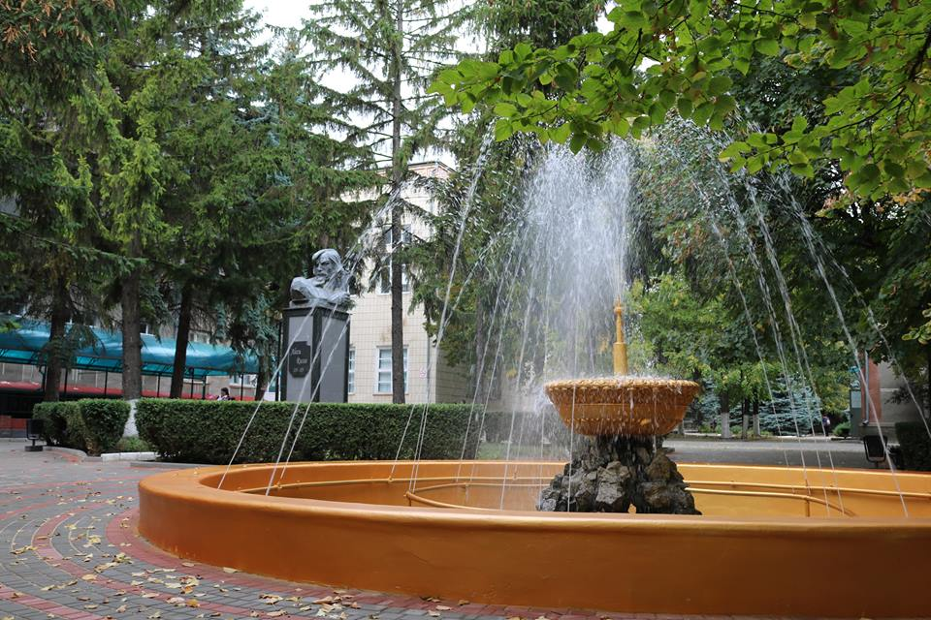

**A great opportunity** to new (or not so new) researchers to present their research project to the colleagues at the Alecu Russo Balti State University.

CO-ORGANIZERS

Mathematical Society of the Republic of Moldova

Institute of Mathematics and Computer Science, Chisinau, Republic of Moldova

Tiraspol State University, Chisinau, Republic of Moldova

Alexandru Ioan Cuza University, Iasi, Romania

Vasyl' Stus Donetsk National University, Vinnytsia, Ukraine

SPONSORS





**For any questions related to the organization:**

**E-mail:** [**miti2018@usarb.md**](mailto:miti2018@usarb.md)

**Phone: +373 231 52488**

**University web-site: www.usarb.md**





**INVITATION**

***Dear colleagues,***

The organization of the international conference dedicated to the illustrious scientist Valentin Belousov is a tribute to the work done both as a teacher and head of the Department of Mathematics at Alecu Russo Balti State University, researcher at the Institute of Mathematics of Academy of Sciences of Moldova, but also as a wellknown researcher in the Republic of Moldova and abroad.

The main goal is to offer a place for meetings and participation in discussions of both experienced and young researchers from the Republic of Moldova and from other countries.

**Conference Topics**

**Theoretical Mathematics:**

* Algebra and Logic
* Geometry and Topology

**Computer Science & IT:**

* Theory of computing Artificial intelligence
* Data mining and knowledge discovery
* Cryptography and security
* Aspects of software system development

**Didactics:**

* Curricula Session
* Planning E-learning issues
* New Technologies for Science
* Teaching Science Teaching Methods.”

**Invited Speakers**

Jon D. Phillips, Professor of Mathematics, Northern Michigan University, USA

Martin Valcke, Professor ‘Instructional Sciences’, Ghent University, Belgium

Toma Albu, Professor of Mathematics, Institute of Mathematics of the Romanian Academy, Romania

**When?**

April 19 – 21, 2018

**Where?**

38, str. Pushkin, Balti, Republic of Moldova